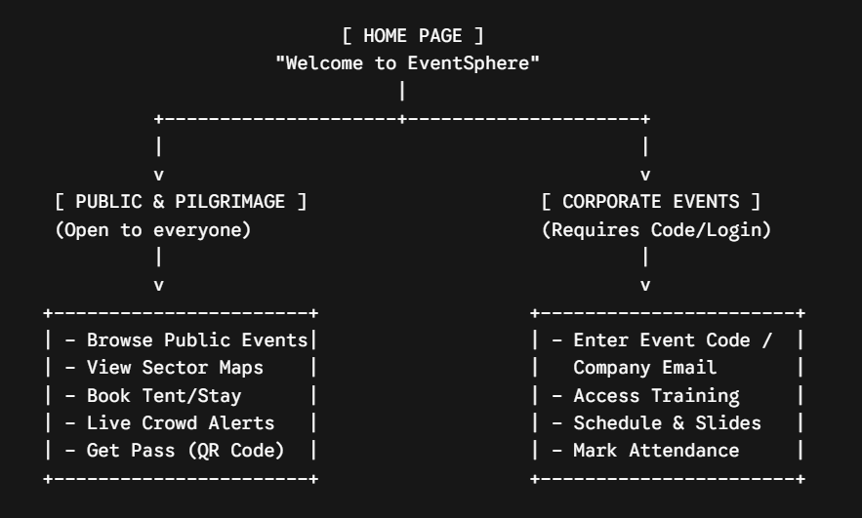

A. The Home Page (The First Screen)
When someone opens your website, they don't see a giant chaotic dashboard. They see two clear options:
- "Explore Public & Cultural Festivals" (For crowds, pilgrimages, public gatherings)
- "Join a Corporate / Private Event" (For companies, employee training, closed workshops)

B. If They Choose "Public & Cultural Festivals"
- Browsing: They select an event (e.g., Kumbh Mela 2026).
- Interactive Map & Sector Guide: They see a digital map showing Sectors (Nagars), Medical Camps, Sanitation Centers, and Main Stages.
- Temporary Stay Booking: They can search for available semi-permanent housing (e.g., Sector 3 -> Tent Block B -> Bed 12) and book it for specific dates.
- Pass & QR Code: Once booked, the app generates a digital QR Pass for entry.
- Live Alerts: Emergency SOS, crowd congestion updates, or schedule changes pop up on their screen in real time.

C. If They Choose "Corporate & Private Events"
- Access Barrier: They enter an Event Access Code or sign in with their registered company email.
- Private Dashboard: Once inside, they see company training schedules, session links, downloadable slides/PDFs, and live feedback forms.
- Attendance: They scan a QR code at the hall entrance to automatically log their attendance for certifications.
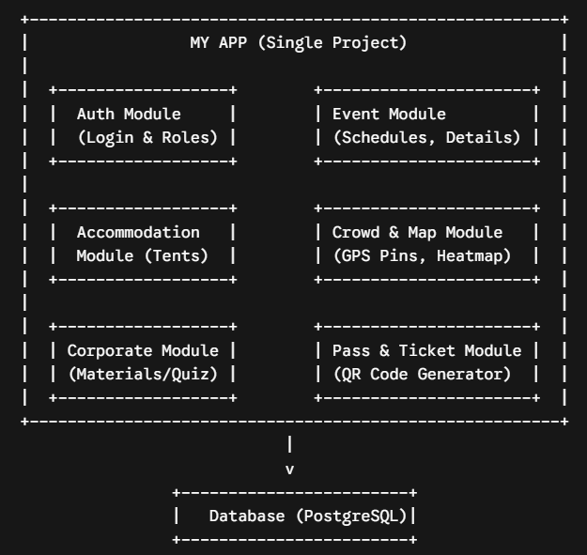

The 6 Main Modules Explained Simply
- User & Auth Module: Handles Sign Up, Login, and User Roles (Super Admin, Organizer, Attendee, Security Guard).
- Event Management Module: Handles creating events, defining whether an event is Public or Corporate, and adding schedules/speakers.
- Accommodation & Stay Module: Manages temporary housing structures (Zone/Sector - Tent/Dorm - Room/Bed number) and availability dates.
- Crowd & Interactive Map Module: Holds GPS coordinates for sector maps, emergency centers, lost & found booths, and crowd density flags (Green = Clear, Red = Heavy Crowd).
- Ticketing & QR Pass Module: Creates entry passes with downloadable QR codes for attendees to show at gates.
- Corporate Training Module: Manages private access codes, document/slide sharing, attendance tracking, and feedback forms.
Category | Component / Tool | Purpose in Your Event Management App | Cost / License
Backend & DB Platform | Supabase | Core database (PostgreSQL), built-in Auth (JWT/Roles), Real-time event triggers, and Storage Buckets for corporate files. | Free Tier (Up to 50k monthly active users)
GIS / Spatial DB | PostGIS Extension | Runs inside Supabase. Stores geographic polygons for festival sectors, tent blocks, and emergency routes to run proximity searches. | Included free inside Supabase
Frontend Framework | Next.js (React Framework) | Framework for building fast, server-rendered web pages, handling dynamic URLs (/events/[id]), and serving offline-first PWAs. | Open Source (Free)
UI Styling | Tailwind CSS | Utility-first CSS framework for rapid UI styling, ensuring your app looks clean and responsive on mobile browsers. | Open Source (Free)
UI Component Library | shadcn/ui | Pre-built UI components (Modals, Tables, Tabs, Buttons, Forms) that plug straight into Next.js and Tailwind CSS. | Open Source (Free)
Interactive Maps | Leaflet.js + react-leaflet | Lightweight mapping engine to render sector layouts, interactive tent pins, heatmaps, and emergency exit routes. | Open Source (Free)
QR Code Generator | qrcode.react | Generates digital entry passes with unique QR codes for tent bookings and corporate attendance. | Open Source (Free)
QR Code Scanner | html5-qrcode | Uses the smartphone or laptop camera at entry gates to scan QR passes for instant check-in verification. | Open Source (Free)
Offline & Mobile PWA | Next.js Native PWA (manifest.json + Service Workers) | Enables "Add to Home Screen" on mobile devices and caches offline maps and QR passes for spotty network environments. | Open Source (Free)
Deployment / Hosting | Vercel | Free global web hosting for Next.js web applications, offering continuous deployment directly from your GitHub repository. | Free Tier
Development Tools | VS Code + Node.js (v20+) | Primary code editor and JavaScript runtime environment required for building and running your Next.js project. | Free

